Department of Veterans Affairs

VistAWeb (NVW) Version 16.1.2



Production Installation Guide

Department of Veterans Affairs
Office of Information and Technology
Product Development

Revision History
Date | Version | Description | Authors
12/19/2011 | 0.01 | Initial Draft | Doug Larsen
1/31/2012 | 0.02 | Technical Review | Dena Lebo, Tim Geffre, Gary Tomlinson
2/29/2012 | 1.0 | Released to AITC | Doug Larsen
2/29/2012 | 1.01 | Edited to meet AITC specification | Doug Larsen
3/1/2012 | 1.02 | Removed SQL scripts | Doug Larsen
3/1/2012 | 1.03 | Reviewed and updated with AITC | Doug Larsen
3/6/2010 | 1.04 | Changed for AITC Install | Doug Larsen
3/12/2012 | 1.05 | Post Installation changes | Doug Larsen
04/28/2012 | 1.06 | TWR 1. | Nick Metrokotsas, Technical Writer.
05/29/2012 | 1.07 | Changes made from the NVW V16 Pre-Prod Release | Terri Rose
5/29/2012 | 1.08 | Updates from NVW V16 Pre-Prod Release | Steve Monson
07/10/2012 | 1.09 | Updates to file names, and script parameters for production. | Steve Monson
9/26/2012 | 1.10 | Updates from NVW V16.1.1 Pre-Prod Release. | Steve Monson, Lead Developer.  Debbie Belle, Configuration Manager.
9/26/2012 | 1.11 | TWR 1. | Nick Metrokotsas, Technical Writer.
5/5/2013 | 1.12 | Patch corrects multiple VistA WEB partners’ Continuity of Care Document (CCD) data. | Sasa Katic, Developer  Bob Sutton, Technical Writer
9/2013 | 1.13 | Multiple changes for patch 28. | Sasa Katic, Developer  Bob Sutton, Technical Writer

Table of Contents
1 VistAWeb Production Environment 1
2 Installation Considerations 2
2.1 Backing up the System 2
2.2 Retrieving Files from Staging Location 2
2.2.1 Application Staging Area 3
2.2.2 Database Scripts Staging Area 3
3 Setting up the Second Database Server 4
3.1 Scripted Setup of SQL Server on VAAUSNVWSQL201 4
3.1.1 Establish Database 4
3.1.2 Create Tables 6
3.1.3 Create Index 7
3.1.4 Create Database Application Role 8
3.1.5 Create Application Login 8
3.2 Management of Log Tables on SQL Server on VAAUSNVWSQL201 9
4 Installing the VistAWeb Sortware on the Web201 Server 9
4.1 Technical Background 10
4.2 Gathering Required Information 10
4.3 VistAWeb Web Server Software Installation Detailed Steps 12
4.3.1 Step 1: Retrieve the VistAWeb Release Package 12
4.3.2 Step 2: Unpack the Scripts 12
4.3.3 Step 3: Set Up the Powershell Execution Environment 14
4.3.4 Step 4: Run the VistAWeb Delete Script 15
4.3.5 Step 5: Run the VistAWeb install Script (with parameters) 15
4.4 Installing VistAWeb Using a Pre-completed Command File 16
5 Installing the VistAWeb Software on the Web200 Server 17
5.1 Gathering Required Information 17
5.2 VistAWeb Web Server Software Installation Detailed Steps 18
5.2.1 Step 1: Retrieve the VistAWeb Release Package 18
5.2.2 Step 2: Unpack the Scripts 19
5.2.3 Step 3: Set Up the Powershell Execution Environment 20
5.2.4 Step 4: Run the VistAWeb Delete Script 21
5.2.5 Step 5: Run the VistAWeb install Script (with parameters) 21
5.3 Installing VistAWeb Using a Pre-completed Command File 22
6 Backout Plan 23
Appendix A 24

List of Tables
Table 1: VistAWeb Production Environment Virtual Machines 1
Table 2: Staging Information for the Web Servers (VAAUSNVWWEB200 and VAAUSNVWWEB201) 3
Table 3: Parameters Required by the VistAWeb Install Script for IOC 11
Table 4: Parameters Required by the VistAWeb Install Script 17

List of Figures
Figure 1: SQL Query 1.sql 6
Figure 2: SQL Query2 .sql 7
Figure 3: SQL Query 2 .sql 9
Figure 4: d:\data\download\vistaweb\v1612\T2 folder 13
Figure 5: Extracting the Windows2008Setup ZIP File 14
Figure 6: Correct PowerShell Command Execution Environment 15
Figure 7: d:\data\download\vistaweb\v1612\T2 folder 19
Figure 8: Extracting the Windows2008Setup ZIP File 20
Figure 9: Example PowerShell Command Execution Environment 21

VistAWeb Production Environment
This section provides VistAWeb system component information for the Production environment, normally referred to as Prod.
The Prod environment is deployed on the Virtual Machines (VMs) listed in Table 1 below. These VMs are hosted on the existing AITC VM Farm.
IMPORTANT NOTE: For the Austin Production Environment only the Web Server: VAAUSNVWWEB200 (Windows) and the two Database Servers: VAAUSNVWSQL200 (Windows) and VAAUSNVWSQL201 (Windows) will be used.
Table 1: VistAWeb Production Environment Virtual Machines
Name of VM | Server features on the VM
Web Server:  VAAUSNVWWEB200 | Operating System (OS): Microsoft Windows Server 2008 R2 SP1 (64-bit)  Web Server: Microsoft Internet Information Services (IIS) version 7.5  Microsoft DotNet Framework version 4.0  12 GB Memory (RAM)  4 vCPUs  C:\ OS 40 GB  D:\ App 50 GB  L:\ Logs 200 GB
Web Server:  VAAUSNVWWEB201 (Windows) | Operating System (OS): Microsoft Windows Server 2008 R2 SP1 (64-bit)  Web Server: Microsoft Internet Information Services (IIS) version 7.5  Microsoft DotNet Framework version 4.0  8 GB Memory (RAM)  2 vCPUs  C:\ OS 40 GB  D:\ App 50 GB  L:\ Logs 200 GB
Database Servers:  VAAUSNVWSQL200 (Windows) | Operating System (OS): Microsoft Windows Server 2008 R2 SP1 (64-bt)  Microsoft SQL Server 2008 R2  Microsoft DotNet Framework version 4.0  16 GB Memory (RAM)  2 vCPUs  C:\ OS 40 GB  D:\ App 20 GB  E:\ Data 200 GB  L:\ SQLLogs 40 GB  M:\ FW_Imports 25 GB  T:\ TempDB 50 GB  B:\ Backups 225 GB
Database Servers:  VAAUSNVWSQL201 (Windows) | Operating System (OS): Microsoft Windows Server 2008 R2 SP1 (64-bt)  Microsoft SQL Server 2008 R2  Microsoft DotNet Framework version 4.0  16 GB Memory (RAM)  2 vCPUs  C:\ OS 40 GB  D:\ App 20 GB  E:\ Data 200 GB  L:\ SQLLogs 20 GB  T:\ TempDB 50 GB  B:\ Backups 200 GB

Installation Considerations
Before actual code can be deployed into the Production environment, you must perform necessary backups of the system and verify that the required files have been dropped into their respective staging areas by the NwHIN VistAWeb Development Team.

Backing up the System
Before the Installation of the SQL database and the VistAWeb application request a snapshot be taken for purpose of being able to restore the Servers to their original configuration before you began the install.

Retrieving Files from Staging Location
The various files associated with the new code must first be dropped by the NwHIN VistAWeb Development team into staging areas.

Application Staging Area
Create the following folder on the VAAUSNVWWEB200 server.
D:\data\download\vistaweb\v1612\T2

This location will be referred to in this document as the <APP_STAGE> location of the VistAWeb installation files.

The NwHIN VistAWeb Development team drops files for the VAAUSNVWWEB200 server here.

\\Vadevmul01\nhin\NHIN-Staging\NVW\PROD\v1612

Note: Depending on how many build versions there are, there could be a number of different folders in \v1612\ folder. These will be named ‘T’ followed by the build number (ex. \v1612\T3). VistAWeb Development team will put the latest files in the lates version (highest T number).

From this location, copy the files there to the <APP_STAGE> folder.
Table 2: Staging Information for the Web Servers (VAAUSNVWWEB200 and VAAUSNVWWEB201)
Staging Folder Alias | New Files to Copy
<APP_STAGE> | - vistaweb_COMPLETE_16.1.2.T2.7.4.2013.zip

No database changes. Skip to Section 4.

Database Scripts Staging Area
Create the following folder on the VAAUSNVWSQL201 server.
D:\data\download\vistaweb\v1612\DBS

This location will be referred to in this document as the <DBS_STAGE> location of the VistAWeb database installation files.

The NwHIN VistaWeb Development team drops files for the VAAUSNVWSQL201 server here.
\\vadevmul01\NHIN\NHIN-Staging\NVW\PROD\v1612\T2\DBS

From this location, copy the files there to the <DBS_STAGE> folder.
Staging Folder Alias | New Files to Copy
<DBS_STAGE> | - CREATE_APPLICATION_LOGIN_logger.sql  - CREATE_APPLICATION_ROLE_vw_logging.sql  - CREATE_DB_EMR_UTIL.sql  - CREATE_TABLE_Log4net1.sql  - CREATE_TABLE_Log4net1_index.sql  - CREATE_TABLE_Log4net2.sql

Setting up the Second Database Server
The secondary VistAWeb database server, on VAAUSNVWSQL201, will now be used to capture and retain the application error logs. VistAWeb uses a logging framework called Log4net, similar to Log4j in the Java world, to manage code level logging events. Before installation of VistAWeb version 16.1, all logging was captured in the LoggerTable table and the BiggerLogger table in the VAAUSNVWSQL200 database server. With installation of VistAWeb version 16.1.2, all of this logging will now be captured in two tables called Log4net1 and Log4net2 in the VAAUSNVWSQL201 server.
The following scripts will allow an administrator to create a new database called EMR_UTIL, two new tables called Log4net1 and Log4net2, one new index for the Log4net1 table, an application role with table WRITE rights for the two new tables, and an application login that uses the application role.

Scripted Setup of SQL Server on VAAUSNVWSQL201

Establish Database
Execute the following script on the server, called CREATE_DB_EMR_UTIL.sql in the <DBS_STAGE> folder. It creates a database called EMR_UTIL.
USE [master]
GO

CREATE DATABASE [EMR_UTIL] ON PRIMARY
( NAME = N'EMR_UTIL', FILENAME = N'D:\SQLData\EMR_UTIL.mdf' , SIZE = 3072KB , MAXSIZE = UNLIMITED, FILEGROWTH = 10%)
LOG ON
( NAME = N'EMR_UTIL_log', FILENAME = N'L:\SQLLogs\EMR_UTIL_log.ldf' , SIZE = 4224KB , MAXSIZE = 2048GB , FILEGROWTH = 10%)
GO

ALTER DATABASE [EMR_UTIL] SET COMPATIBILITY_LEVEL = 100
GO

IF (1 = FULLTEXTSERVICEPROPERTY('IsFullTextInstalled'))
begin
EXEC [EMR_UTIL].[dbo].[sp_fulltext_database] @action = 'enable'
end
GO

ALTER DATABASE [EMR_UTIL] SET ANSI_NULL_DEFAULT OFF
GO
ALTER DATABASE [EMR_UTIL] SET ANSI_NULLS OFF
GO
ALTER DATABASE [EMR_UTIL] SET ANSI_PADDING OFF
GO
ALTER DATABASE [EMR_UTIL] SET ANSI_WARNINGS OFF
GO
ALTER DATABASE [EMR_UTIL] SET ARITHABORT OFF
GO
ALTER DATABASE [EMR_UTIL] SET AUTO_CLOSE OFF
GO
ALTER DATABASE [EMR_UTIL] SET AUTO_CREATE_STATISTICS ON
GO
ALTER DATABASE [EMR_UTIL] SET AUTO_SHRINK OFF
GO
ALTER DATABASE [EMR_UTIL] SET AUTO_UPDATE_STATISTICS ON
GO
ALTER DATABASE [EMR_UTIL] SET CURSOR_CLOSE_ON_COMMIT OFF
GO
ALTER DATABASE [EMR_UTIL] SET CURSOR_DEFAULT GLOBAL
GO
ALTER DATABASE [EMR_UTIL] SET CONCAT_NULL_YIELDS_NULL OFF
GO
ALTER DATABASE [EMR_UTIL] SET NUMERIC_ROUNDABORT OFF
GO
ALTER DATABASE [EMR_UTIL] SET QUOTED_IDENTIFIER OFF
GO
ALTER DATABASE [EMR_UTIL] SET RECURSIVE_TRIGGERS OFF
GO
ALTER DATABASE [EMR_UTIL] SET DISABLE_BROKER
GO
ALTER DATABASE [EMR_UTIL] SET AUTO_UPDATE_STATISTICS_ASYNC OFF
GO
ALTER DATABASE [EMR_UTIL] SET DATE_CORRELATION_OPTIMIZATION OFF
GO
ALTER DATABASE [EMR_UTIL] SET TRUSTWORTHY OFF
GO
ALTER DATABASE [EMR_UTIL] SET ALLOW_SNAPSHOT_ISOLATION OFF
GO
ALTER DATABASE [EMR_UTIL] SET PARAMETERIZATION SIMPLE
GO
ALTER DATABASE [EMR_UTIL] SET READ_COMMITTED_SNAPSHOT OFF
GO
ALTER DATABASE [EMR_UTIL] SET HONOR_BROKER_PRIORITY OFF
GO
ALTER DATABASE [EMR_UTIL] SET READ_WRITE
GO
ALTER DATABASE [EMR_UTIL] SET RECOVERY FULL
GO
ALTER DATABASE [EMR_UTIL] SET MULTI_USER
GO
ALTER DATABASE [EMR_UTIL] SET PAGE_VERIFY CHECKSUM
GO
ALTER DATABASE [EMR_UTIL] SET DB_CHAINING OFF
GO

Figure 1: SQL Query 1.sql
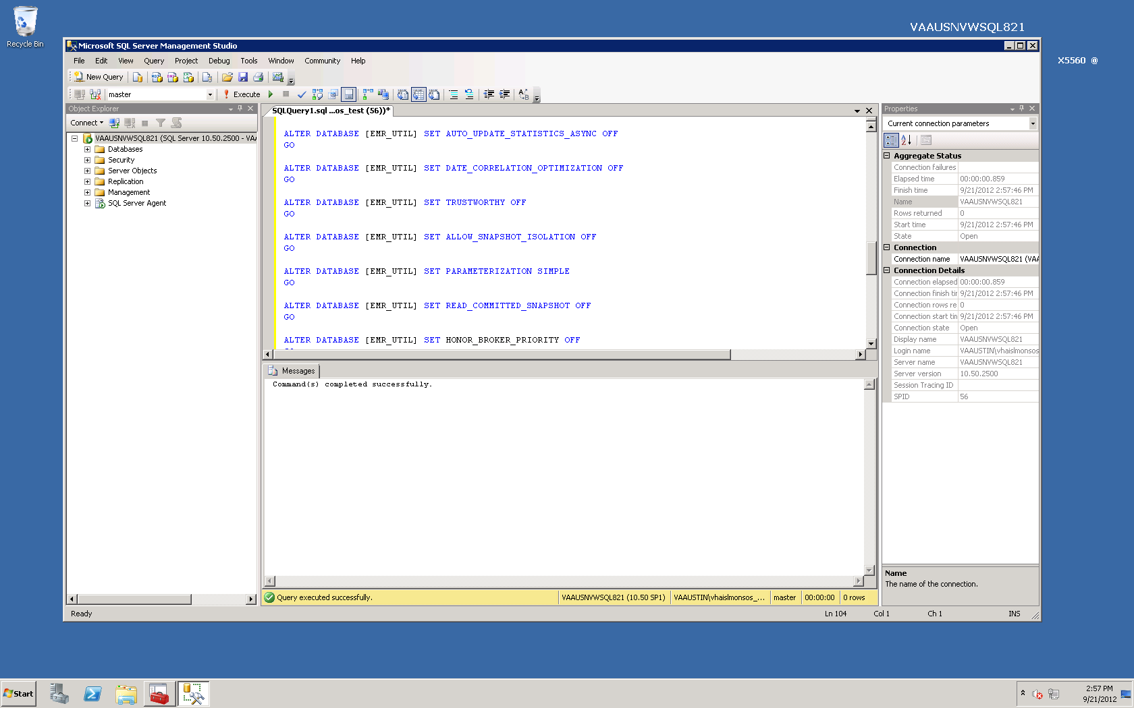

Create Tables
Execute the following scripts on the server to create the tables Log4net1 and Log4net2, called CREATE_TABLE_Log4net1.sql and CREATE_TABLE_Log4net2.sql from the <DBS_STAGE> folder.
USE [EMR_UTIL]
GO
CREATE TABLE [dbo].[Log4net1] (
[Id] [int] IDENTITY (1, 1) NOT NULL,
[Date] [datetime] NOT NULL,
[Thread] [varchar] (255) NOT NULL,
[Level] [varchar] (50) NOT NULL,
[Logger] [varchar] (255) NOT NULL,
[Message] [varchar] (4000) NOT NULL,
[Exception] [varchar] (2000) NULL
)

USE [EMR_UTIL]
GO
CREATE TABLE [dbo].[Log4net2](
[Id] [int] IDENTITY(1,1) NOT NULL,
[Date] [datetime] NOT NULL,
[Thread] [varchar](255) NOT NULL,
[Level] [varchar](50) NOT NULL,
[Logger] [varchar](255) NOT NULL,
[Message] [text] NULL,
[Exception] [varchar](2000) NULL
) ON [DEFAULT] TEXTIMAGE_ON [DEFAULT]
GO

Figure 2: SQL Query2 .sql
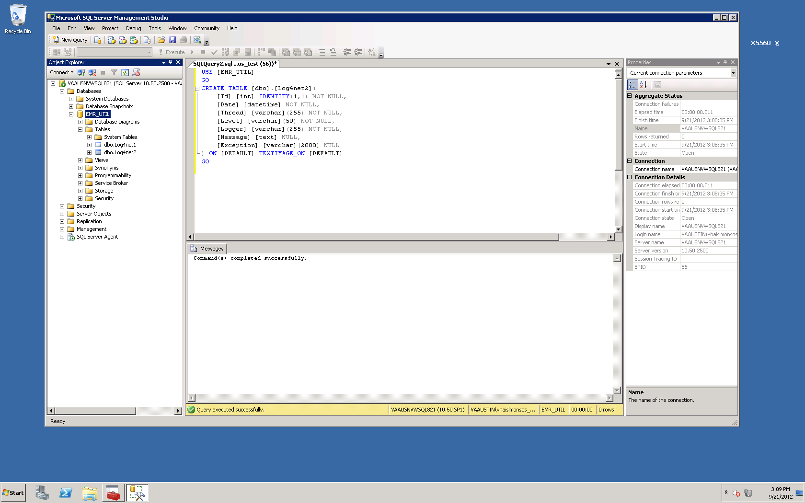

Create Index
Execute the following script on the server to create an index for the Log4net1 table, called CREATE_TABLE_Log4net1_index.sql from the <DBS_STAGE> folder.
USE [EMR_UTIL]
GO
CREATE NONCLUSTERED INDEX [Date_nc_idx]
ON [dbo].[Log4net1] ([Date] ASC)
WITH (PAD_INDEX = OFF,
FILLFACTOR = 100,
IGNORE_DUP_KEY = OFF,
STATISTICS_NORECOMPUTE = OFF,
ONLINE = OFF,
ALLOW_ROW_LOCKS = ON,
ALLOW_PAGE_LOCKS = ON,
SORT_IN_TEMPDB = OFF,
DROP_EXISTING = OFF)
ON [PRIMARY];
GO

Create Database Application Role
Execute the following script on the server, which creates a database role called “vw_logging”, used by the VistAWeb applications (web apps). This script is called CREATE_APPLICATION_ROLE_vw_logging.sql in the <DBS_STAGE> folder.
USE [EMR_UTIL]
GO
CREATE ROLE [vw_logging] AUTHORIZATION [dbo]
GO
use [EMR_UTIL]
GO
GRANT INSERT ON [dbo].[Log4net1] TO [vw_logging]
GO
use [EMR_UTIL]
GO
GRANT REFERENCES ON [dbo].[Log4net1] TO [vw_logging]
GO
use [EMR_UTIL]
GO
GRANT INSERT ON [dbo].[Log4net2] TO [vw_logging]
GO
use [EMR_UTIL]
GO
GRANT REFERENCES ON [dbo].[Log4net2] TO [vw_logging]
GO

Create Application Login
Execute the following script on the server. Before doing so, the person reading this text and executing the script must choose an application login name and application login password for this login and substitute these values in the script below. The password chosen must be at least 8 characters long, and contain at least one special character, one number, and one upper-case character. This script is called CREATE_APPLICATION_LOGIN_logger.sql in the <DBS_STAGE> folder.
USE [master]
GO
CREATE LOGIN [XXX_USER_NAME] WITH PASSWORD=N'XXX_LOGGING_PASSWORD', DEFAULT_DATABASE=[EMR_UTIL], CHECK_EXPIRATION=OFF, CHECK_POLICY=ON
GO
USE [EMR_UTIL]
GO
CREATE USER [XXX_USER_NAME] FOR LOGIN [XXX_USER_NAME]
GO
USE [EMR_UTIL]
GO
EXEC sp_addrolemember N'vw_logging', N'XXX_USER_NAME'
GO

Figure 3: SQL Query 2 .sql
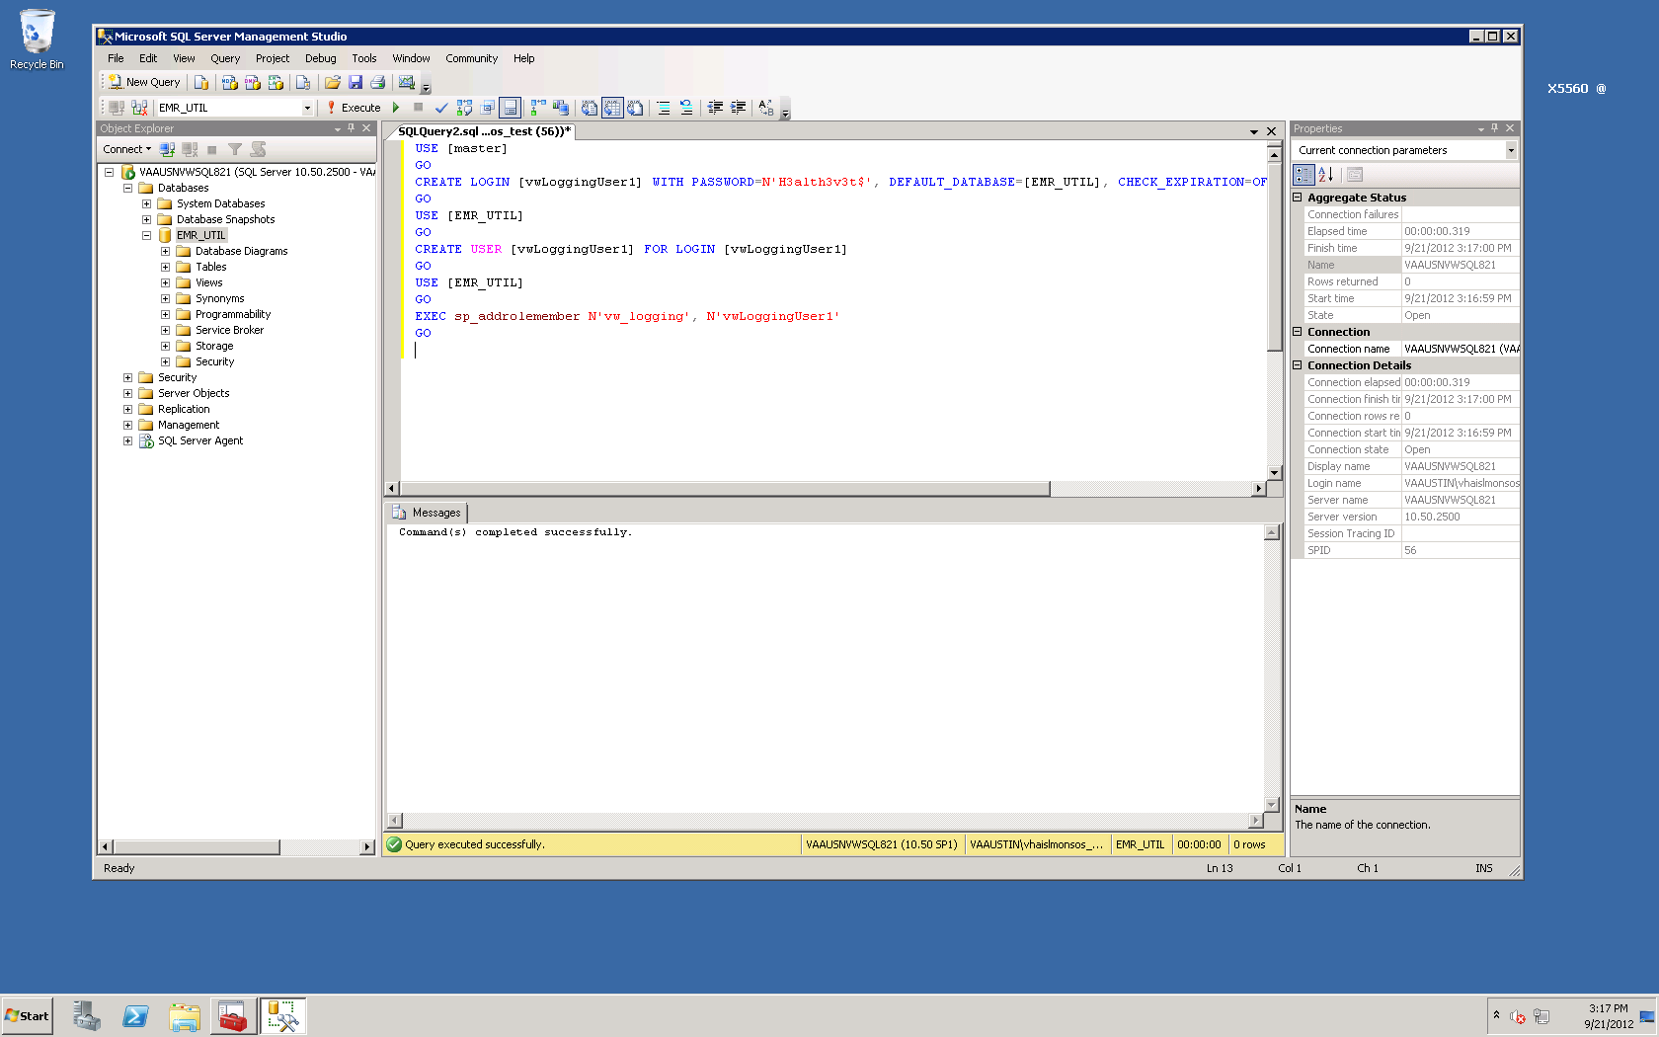

Management of Log Tables on SQL Server on VAAUSNVWSQL201
In order to keep the log table Log4net2 in a manageable size, a script should be setup to execute daily, to keep the last 30 days of logging data. The script should execute the following query.
USE [EMR_UTIL]
GO

DELETE FROM Log4net1
WHERE DATE < dateadd(day, -30, current_timestamp)
GO

Installing the VistAWeb Sortware on the Web201 Server
With the database changes completed, the VistAWeb software can now be installed on the vaausnvwweb201 web server. This instance will be called the “IOC” instance.
If this is the Prod install, skip to Section 5.

Technical Background
When a single VistAWeb instance is installed on a single server, three web sites are created and one application (the root application) is created for each site. Each site has one or two application pools so the structure created on IIS in this case is as follows.
- “vw” web site (“vw” app pool)
  - “vw” web app*
- “vwContext” web site (“vwContext” app pool)
  - “vwContext” web app*
- “vwMeans” web site (“vw_default” app pool)
  - “vwEncrypt” web app (“vwEncrypt” app pool)
*= The server won’t show the web app name because it is integrated into the web site.
The reason the “vwMeans” web site contains an app with a different name, is because “vwMeans” is reserved to host more internal VistAWeb services in the future. You’ll also note that there are four application pools for the arrangement above. This is because web application subordinates of “vwMeans” (in this case vwWencrypt) need their own respective application pools.
Since ASP.net applications can run side-by-side on the same server (even with different .Net frameworks), the VistAWeb install scripts are designed to create any number of VistAWeb instances on a single server. If multiple instances of VistAWeb are hosted on one server (different test versions, for example), each one of these instances is called a “named instance” of VistAWeb on the server. The name of the instance is used as a sort of name spacing convention for setting up the web applications and their application pools. In other words, the instance name is used as part of a naming convention which keeps the web applications and their application pools from colliding.
Here’s an example of how the Prod instance of VistAWeb could be setup on a server.
- “vw” web site (“vw_default” app pool)
  - “ prod” web app (“vw_prod” app pool)
- “vwContext” web site (“vw_default” app pool)
  - “ prod” web app (“vwContext_prod” app pool)
- “vwMeans” web site (“vw_default” app pool)
  - “ prod” virtual directory
    - “vwEncrypt” web app (“vwEncrypt_prod” app pool)
The VistAWeb install scripts can set up a single instance VistAWeb environment, or an environment containing multiple named VistAWeb instances.

Gathering Required Information
NOTE: It is much easier in practice to create an environment installation script which calls Install-Ioc.ps1 with all of the command line parameters preset to the correct values. This avoids having to type them in on the command line in real time, which is tedious and error-prone. Details on preparing and executing such an environmental install script will be presented in the next section. Whichever method is chosen, information will need to be gathered to complete the following table prior to install.
Current versions of VistAWeb are installed into IIS using a PowerShell script.
- Install-VistAWeb.ps1
This script takes a number of parameters and it is necessary to provide them in a timely fashion (or the script will time out). The best way to do this is to learn the required values ahead of time and complete the following table.
Attention Windows System Administrator: Be sure to have the Database User ID and password before starting this section.

Table 3: Parameters Required by the VistAWeb Install Script for IOC
Parameter | Value
Script Parameters Entered on the Command Line
-zipFile | D:\data\download\vistaweb\v1612\T2 \vistaweb_COMPLETE_16.1.2.T2.7.4.2013.zip
-installTargetRoot | D:\data\vwinstall
-sitesFile | D:\data\download\vistaweb\v1612\T2\ vhasites_prod_8_20_2013.xml
-testInstance | N
-db_server | VAAUSNVWSQL200
-db_name | EMR
-db_userId | (Created when the EMR database was created and the role VW_APPLICATION script was installed in version 15.0.0 of VistAWeb)
-vistaSecPhrase | WE'RE HERE FOR VETS (Note; this parameter is case sensitive)
-awivSecPhrase | VISTA IMAGING AWIV (Note; this parameter is case sensitive)
-showVersion | N
-db_server_logging | VAAUSNVWSQL201
-db_name_logging | EMR_UTIL
-db_userId_logging | (Created when the EMR_UTIL database was created via script in section 3.1.5)
Parameters Entered When the Script Runs
vw IP address | 10.224.80.66
Site name for host header | Should be left blank
Vw certificate number | Select certificate associated to “ioc.vistaweb.med.va.gov”
vwContext port number | 19989
vwContext IP address | 10.224.80.255
vwMeans port number | 18988
vwMeans IP address | 10.224.81.0
“Create a single installation of VistAWeb? (Enter 'Y' to continue)” | Type Y and press <enter> when this prompt appears.
“Enter the VistAWeb application database user password:” | Type in the database application user password and press <enter> (the screen will show *’s when the password is entered)
“Enter the VistAWeb logging database user password:” | Type in the database logging user password (as created in section 3.1.5 of this document) and press <enter> (the screen will show *’s when the password is entered)

VistAWeb Web Server Software Installation Detailed Steps

Step 1: Retrieve the VistAWeb Release Package
- Log in to the server where VistAWeb will be installed.
- Copy the latest ‘T#’ folder from \\vadevmul01\NHIN\NHIN-Staging\NVW\PROD\v1612 to d:\data\download\vistaweb\v1612.

Step 2: Unpack the Scripts
- View the content of the vistaweb_COMPLETE_16.1.2.T2.7.4.2013.zip ZIP file by double-clicking it.
- Highlight the ZIP file called Windows2008Setup.16.1.2.zip and right click and select “copy”.
- Click the “back” button on the file explorer window to go up a level, and then press <Ctrl>-V to paste the Windows2008Setup.16.1.2.zip folder. When this operation is complete, you should have two zip files in the d:\data\download\vistaweb\v1612\T2 folder, as shown in the figure below.

Figure 4: d:\data\download\vistaweb\v1612\T2 folder
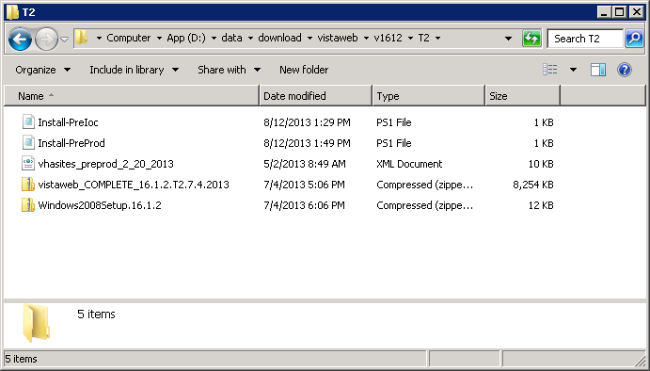
- Unzip the Windows2008Setup.16.1.2.zip ZIP file in the current directory. Right-click the file and select “Extract All…”, then in the “Extract Compressed (Zipped) Folders” dialog folder click the “Extract” button.
- Next, move file ‘Install-IOC’ from /T2 folder to the new unzipped ‘Windows2008Setup.16.1.2’ folder.
You should have this view when completed.
Figure 5: Extracting the Windows2008Setup ZIP File
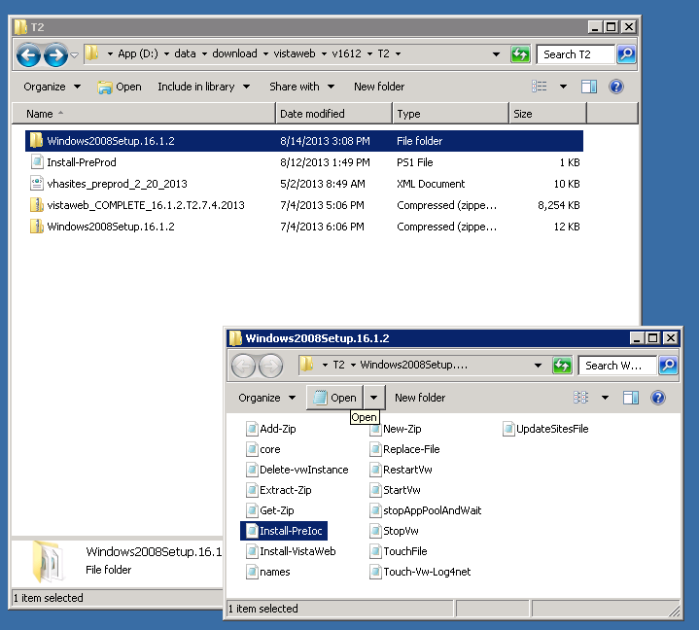

Step 3: Set Up the Powershell Execution Environment
- Start up the Powershell command shell by clicking the blue icon on the Task bar. It is in the lower left corner of the window next to the start button.
- Execute the command “Set-Location D:\data\Download\vistaweb\v1612\T2\Windows2008Setup.16.1.2”
The following figure shows how the powershell command environment looks after the execution environment has been set up correctly.
Figure 6: Correct PowerShell Command Execution Environment
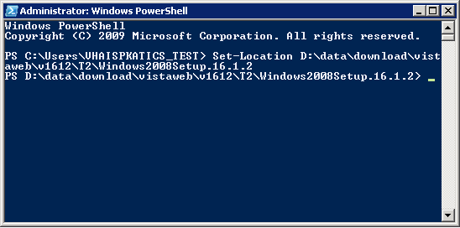

Step 4: Run the VistAWeb Delete Script
The procedure in this section is to remove any prior instances of VistaWeb.
- Open PowerShell if not already open.
- Change the working directory to the one shown in 4.3.3 if not already there.
- Run the script called Delete-vwInstance.ps1 without any parameters. Type in .\Delete-vwInstance.ps1 and press <Enter> to execute it.

Step 5: Run the VistAWeb install Script (with parameters)
The procedure in this section asks you to enter each of the parameters required by the install script contained in table 6 at the command line. The use of a pre-completed command file (as described in the next section) eliminates the need to enter parameters in real time at the command line, which is tedious and error prone.
On the Powershell command line, execute the following command.
.\Install-VistaWeb.ps1 -zipFile "D:\data\Download\vistaweb\ v1612\T2\vistaweb_COMPLETE_ 16.1.2.T2.7.4.2013.zip " -installTargetRoot "D:\data\vwInstall" -sitesFile "D:\data\Download\vistaweb\ v1612\T2\vhasites_prod_8_20_2013.xml " -testInstance "N" -db_server "vaausnvwsql200" -db_name "EMR" -db_userId "xxxxxx" -vistaSecPhrase "WE’RE HERE FOR VETS" -awivSecPhrase "VISTA IMAGIN AWIV" -showVersion "N" -db_server_logging "vaausnvwsql201" -db_name_logging "EMR_UTIL" -db_userId_logging "xxxxxx"
Notes:
- Each parameter value should be enclosed in double quotes.
- The two database user names should be changed from “xxxxxx” to the actual values.
- The parameters can be put on the command line in any order.

You will be prompted for various other input parameters. Enter the values from table 3 for each question.

Once the install script has completed without errors you may verify the installation (i.e., the existence of the right web sites, web applications, and application pools as shown in Section 4.1 Technical Background of this guide).
Note to Windows System Administrator: After the installation has completed, do the following.
- Edit the D:\data\vwinstall\vw\resources\xml\LOG4NET.xml file by adding a blank link to the end of the file.
- Run the automated script,
- Ensure logging is occurring on the Introscope Monitoring graph.

Installing VistAWeb Using a Pre-completed Command File
As mentioned earlier, the easiest way to install the VistAWeb software is to use a pre-completed command file, meaning a command file which invokes the install script with the values of the parameters already entered. We strongly recommend using this procedure in lieu of trying to enter parameters on the command line when executing Install-Ioc.ps1. To use a pre-completed command file, proceed as follows.
1. If you have not done so already:
a. Start Powershell and set up the Powershell execution environment as per the install guide (4.3.3 Step 3: Set up the Powershell Execution Environment).
b. Execute the new install script (for your environment) as a Powershell command. For example ./Install-Ioc.ps1
c. You will be prompted for various other input parameters. Enter the values from table 3 for each question.
2. Once the install script has completed without errors you may verify the installation (i.e., the existence of the right web sites, web applications, and application pools as shown in Section 4.1 Technical Overview of this guide).

Note to Windows System Administrator: After the installation has completed, do the following.
- Edit the D:\data\vwinstall\vw\resources\xml\LOG4NET.xml file by adding a blank link to the end of the file.
- Run the automated script,
- Ensure logging is occurring on the Introscope Monitoring graph.

Installing the VistAWeb Software on the Web200 Server
The next task is to install the VistAWeb software in the Prod instance.

Gathering Required Information
NOTE: It is much easier in practice to create an environment installation script which calls Install-Prod.ps1 with all of the command line parameters preset to the correct values. This avoids having to type them in on the command line in real time, which is tedious and error-prone. Details on preparing and executing such an environmental install script will be presented in the next section. Whichever method is chosen, information will need to be gathered to complete the following table prior to install.

Current versions of VistAWeb are installed into IIS using a PowerShell script.
- Install-VistAWeb.ps1
This script takes a number of parameters and it is necessary to provide them in a timely fashion (or the script will time out). The best way to do this is to learn the required values ahead of time and complete the following table.
Attention Windows System Administrator: Be sure to have the Database User ID and password before starting this section.

Table 4: Parameters Required by the VistAWeb Install Script
Parameter | Value
Script Parameters Entered on the Command Line
-zipFile | D:\data\download\vistaweb\ v1612\T2\vistaweb_COMPLETE_ 16.1.2.T2.7.4.2013.zip
-installTargetRoot | D:\data\vwinstall
-sitesFile | D:\data\download\vistaweb\v1612\T2 \vhasites_prod_8_20_2013.xml
-testInstance | N
-db_server | VAAUSNVWSQL200
-db_name | EMR
-db_userId | (Created when the EMR database was created and the role VW_APPLICATION script was installed in version 15.0.0 of VistAWeb)
-vistaSecPhrase | WE’RE HERE FOR VETS (Note; this parameter is case sensitive)
-awivSecPhrase | VISTA IMAGING AWIV (Note; this parameter is case sensitive)
-showVersion | N
-db_server_logging | VAAUSNVWSQL201
-db_name_logging | EMR_UTIL
-db_userId_logging | (Created when the EMR_UTIL database was created via script in section 3.1.5)
Parameters Entered When the Script Runs
vw IP address | 10.224.81.236
Site name for host header | Should be left blank
Vw certificate number | Select certificate associated to “vistaweb.med.va.gov”
vwContext port number | 19985
vwContext IP address | 10.224.81.237
vwMeans port number | 18988
vwMeans IP address | 10.224.81.238
“Create a single installation of VistAWeb? (Enter 'Y' to continue)” | Type Y and press <enter> when this prompt appears.
“Enter the VistAWeb application database user password:” | Type in the database application user password and press <enter> (the screen will show *’s when the password is entered)
“Enter the VistAWeb logging database user password:” | Type in the database logging user password (as created in section 3.1.5 of this document) and press <enter> (the screen will show *’s when the password is entered)

VistAWeb Web Server Software Installation Detailed Steps

Step 1: Retrieve the VistAWeb Release Package
- Log in to the server where VistAWeb will be installed.
- Copy the latest ‘T#’ folder from \\vadevmul01\NHIN\NHIN-Staging\NVW\PROD\v1612 to d:\data\download\vistaweb\v1612.

Step 2: Unpack the Scripts
- View the content of the vistaweb_COMPLETE_16.1.2.T2.7.4.2013.zip ZIP file by double-clicking it.
- Highlight the ZIP file called Windows2008Setup.16.1.2.zip and right click and select “copy”.
- Click the “back” button on the file explorer window to go up a level, and then press <Ctrl>-V to paste the Windows2008Setup.16.1.2.zip folder. When this operation is complete, you should have two zip files in the d:\data\download\vistaweb\v1612\T2 folder, as shown in the figure below.

Figure 7: d:\data\download\vistaweb\v1612\T2 folder
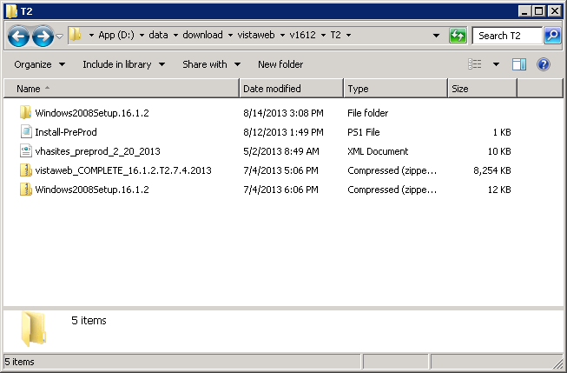

- Unzip the Windows2008Setup.16.1.2.zip ZIP file in the current directory. Right-click the file and select “Extract All…”, then in the “Extract Compressed (Zipped) Folders” dialog folder click the “Extract” button.
- Next, move file ‘Install-Prod’ from T2 folder to the new unzipped ‘Windows2008Setup.16.1.2’ folder.
You should have this view when completed.
Figure 8: Extracting the Windows2008Setup ZIP File
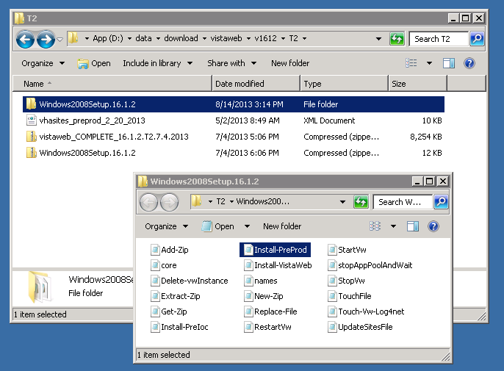

Step 3: Set Up the Powershell Execution Environment
- Start up the Powershell command shell by clicking the blue icon on the Task bar. It is in the lower left corner of the window next to the start button.
- Execute the command “ Set-Location D:\data\Download\vistaweb\ v1612\T2\Windows2008Setup.16.1.2”
The following figure shows how the powershell command environment looks after the execution environment has been set up correctly.
Figure 9: Example PowerShell Command Execution Environment

Step 4: Run the VistAWeb Delete Script
The procedure in this section is to remove any prior instances of VistaWeb.
- Open PowerShell if not already open.
- Change the working directory to the one shown in 4.3.3 if not already there.
- Run the script called Delete-vwInstance.ps1 without any parameters. Type in .\Delete-vwInstance.ps1 and press <Enter> to execute it.

Step 5: Run the VistAWeb install Script (with parameters)
The procedure in this section asks you to enter each of the parameters required by the install script contained in table 6 at the command line. The use of a pre-completed command file (as described in the next section) eliminates the need to enter parameters in real time at the command line, which is tedious and error prone.
On the Powershell command line, execute the following command.
.\Install-VistaWeb.ps1 -zipFile "D:\data\Download\vistaweb\ v1612\T2\vistaweb_COMPLETE_ 16.1.2.T2.7.4.2013.zip " -installTargetRoot "D:\data\vwInstall" -sitesFile "D:\data\Download\vistaweb\ v1612\T2\vhasites_prod_8_20_2013.xml " -testInstance "N" -db_server "vaausnvwsql200" -db_name "EMR" -db_userId "xxxxxx" -vistaSecPhrase "WE'RE HERE FOR VETS" -awivSecPhrase "VISTA IMAGING AWIV" -showVersion "N" -db_server_logging "vaausnvwsql201" -db_name_logging "EMR_UTIL" -db_userId_logging "xxxxxx"
You will be prompted for various other input parameters. Enter the values from table 4 for each question.

Once the install script has completed without errors you may verify the installation (i.e., the existence of the right web sites, web applications, and application pools as shown in Section 4.1 Technical Background of this guide).

Notes:
- Each parameter value should be enclosed in double quotes.
- The two database user names should be changed from “xxxxxx” to the actual values.
- The parameters can be put on the command line in any order.

Note to Windows System Administrator: After the installation has completed, do the following:
- Edit the D:\data\vwinstall\vw\resources\xml\LOG4NET.xml file by adding a blank link to the end of the file.
- Run the automated script,
- Ensure logging is occurring on the Introscope Monitoring graph.

Installing VistAWeb Using a Pre-completed Command File
As mentioned earlier, the easiest way to install the VistAWeb software is to use a pre-completed command file, meaning a command file which invokes the install script with the values of the parameters already entered. We strongly recommend using this procedure in lieu of trying to enter parameters on the command line when executing Install-VistAWeb.ps1. To use a pre-completed command file, proceed as follows.
- If you have not done so already:
  - Start Powershell and set up the Powershell execution environment as per the install guide (5.2.3 Step 3: Set up the Powershell Execution Environment).
  - Execute the new install script (for your environment – the one you just saved with modified parameters) as a Powershell command. For example ./Install-Prod.ps1
  - You will be prompted for various other input parameters. Enter the values from table 4 for each question.
- Once the install script has completed without errors you may verify the installation (i.e., the existence of the right web sites, web applications, and application pools as shown in Section 4.1 Technical Background of this Guide.).

Note to Windows System Administrator: After the installation has completed, do the following:
- Edit the D:\data\vwinstall\vw\resources\xml\LOG4NET.xml file by adding a blank link to the end of the file.
- Run the automated script,
- Ensure logging is occurring on the Introscope Monitoring graph.

Backout Plan
The rollback of the Server to its original configuration before the VistAWeb install can be accomplished in two different methods. If the snapshot is available and untouched you can restore the snapshot back to the original configuration and begin the install again. If this is not available you can also delete the lower directory you created (D:\data\vwinstall) when you installed the application and begin again. To rollback a snapshot you are constrained to the two week time period that the snapshot is held. This installation is estimated to be complete within a one hour period. If due to unforeseen circumstances this installation takes more than four hours without any progress the AITC Project Manager will be asked to continue the operation or to roll back to the bare metal configuration. Many of the updates and changes that are required for the VistAWeb application are scripted and included with the zip file that is used for the original build. So the current procedure is to use those scripts to modify or change the application and the determining factor to remove the application is usually to change to a new version.
Appendix A

Script for Production installation.

Install-Prod.ps1

.\Install-VistaWeb.ps1 -zipFile "D:\data\Download\vistaweb\ v1612\T2\vistaweb_COMPLETE_16.1.2.T2.7.4.2013.zip " -installTargetRoot "D:\data\vwInstall" -sitesFile "D:\data\Download\vistaweb\ v1612\T2\vhasites_prod_8_20_2013.xml " -testInstance "N" -db_server "vaausnvwsql200" -db_name "EMR" -db_userId "xxxxxx" -vistaSecPhrase "WE'RE HERE FOR VETS" -awivSecPhrase "VISTA IMAGING AWIV" -showVersion "N" -db_server_logging "vaausnvwsql201" -db_name_logging "EMR_UTIL" -db_userId_logging "xxxxxx"
Script for IOC installation.
Install-Ioc.ps1
.\Install-VistaWeb.ps1 -zipFile "D:\data\Download\vistaweb\ v1612\T2\vistaweb_COMPLETE_16.1.2.T2.7.4.2013.zip " -installTargetRoot "D:\data\vwInstall" -sitesFile "D:\data\Download\vistaweb\ v1612\T2\vhasites_prod_8_20_2013.xml " -testInstance "N" -db_server "vaausnvwsql200" -db_name "EMR" -db_userId "xxxxxx" -vistaSecPhrase "WE'RE HERE FOR VETS" -awivSecPhrase "VISTA IMAGING AWIV" -showVersion "N" -db_server_logging "vaausnvwsql201" -db_name_logging "EMR_UTIL" -db_userId_logging "xxxxxx"

